Software Lab assessment-5

Project name: Tweet analysis (Tweetify)

Summary of project:

Twitter sentiment analysis is a web application that gives us insights about the tweets or any query and trending topics on twitter. Help know a person's interests based on liked posts. Useful for businesses to target advertisement and promoting their products

There are already several tons of project with Twitter analysis as their base in the software development community, however there are only a handful of software that give precise and free results without signing up or without a credit card information. We wanted to enhance their functionality as well as provide it as an open-source software

Home page

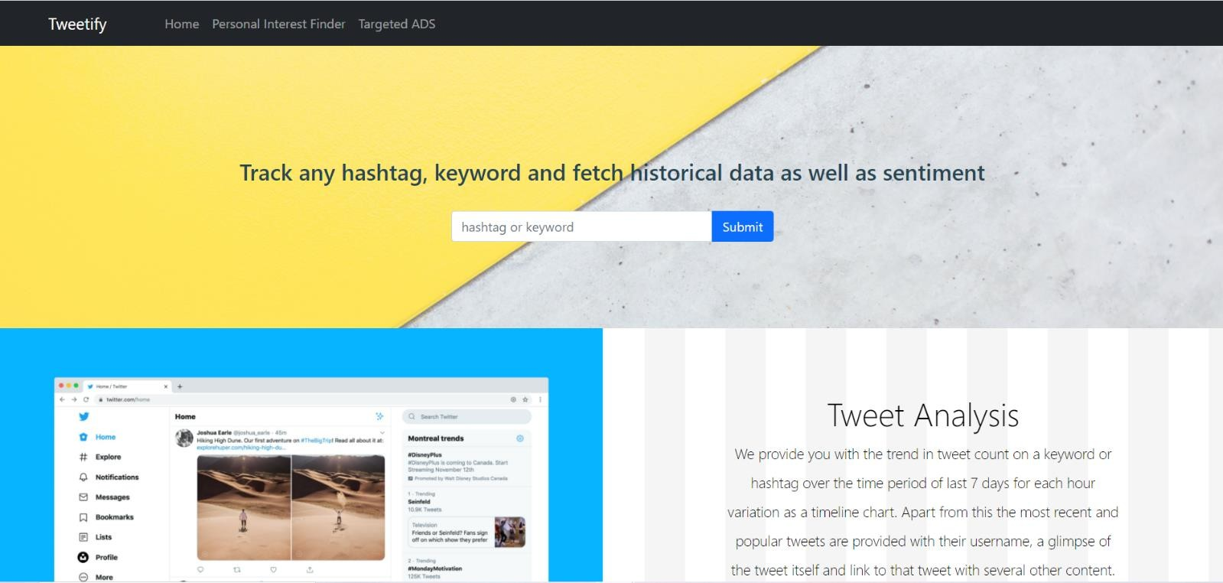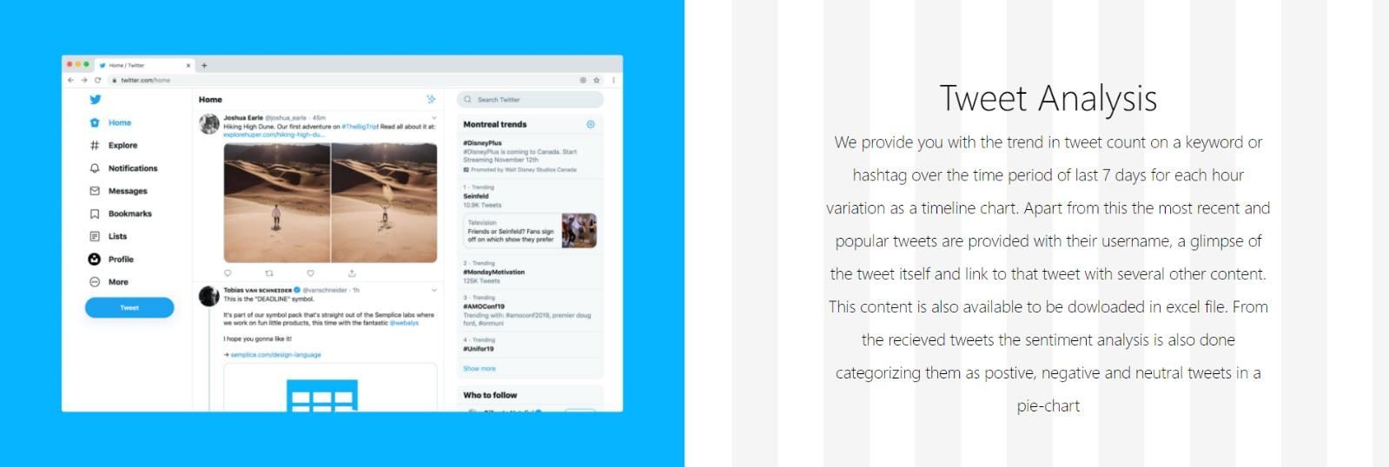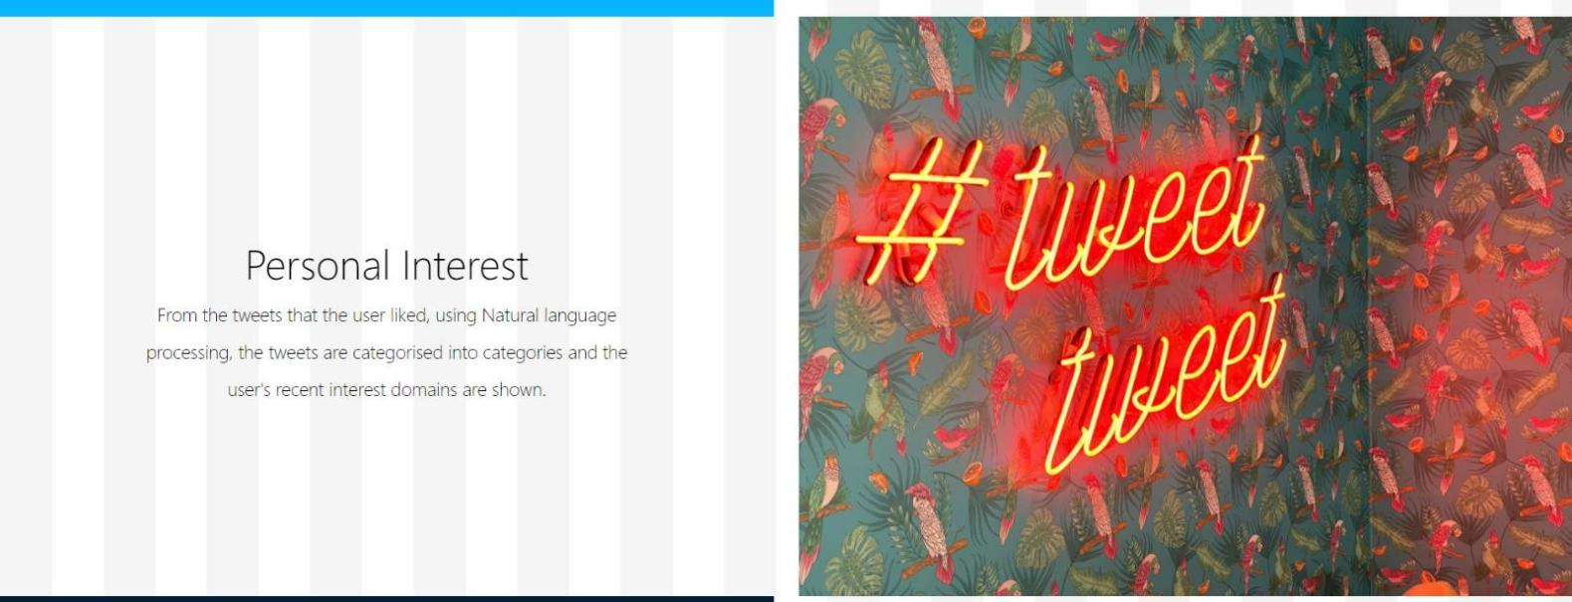



Responsive design:

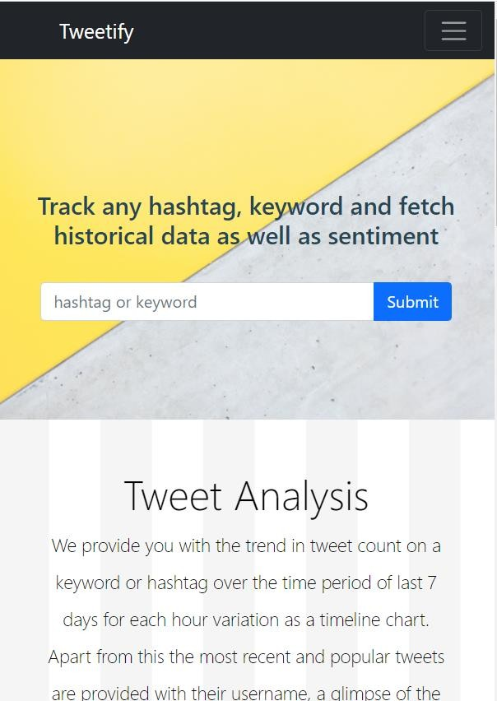

Hashtag or Keyword analysis Tweet count:

Tweet count trend for the last 7days for each hour.

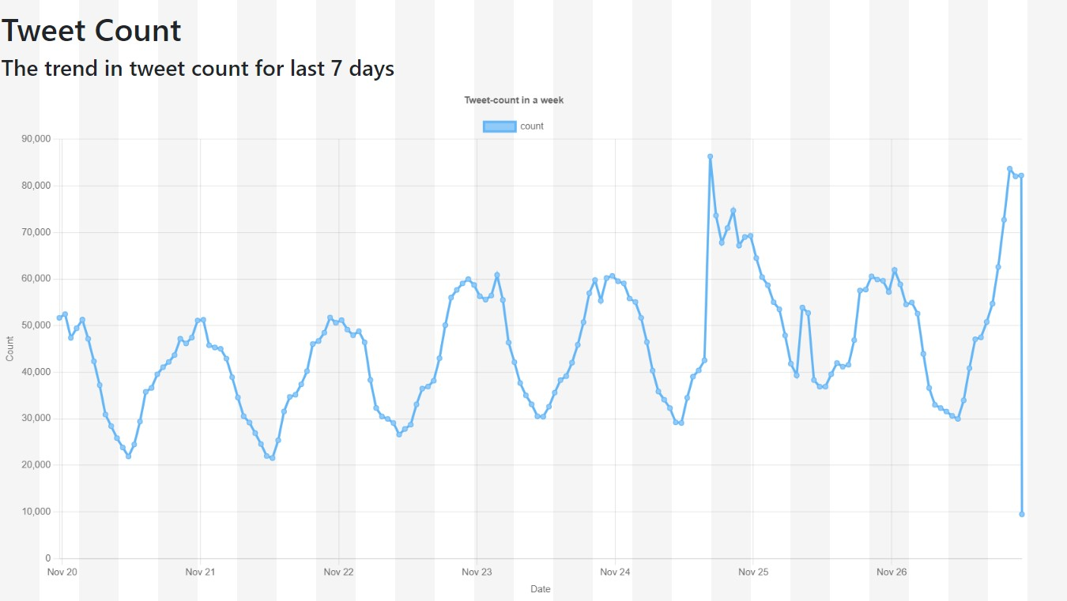

Hashtag analysis – It has the most popular and recent recent tweet on the hashtag or keyword. This result can also be downloaded in excel format.

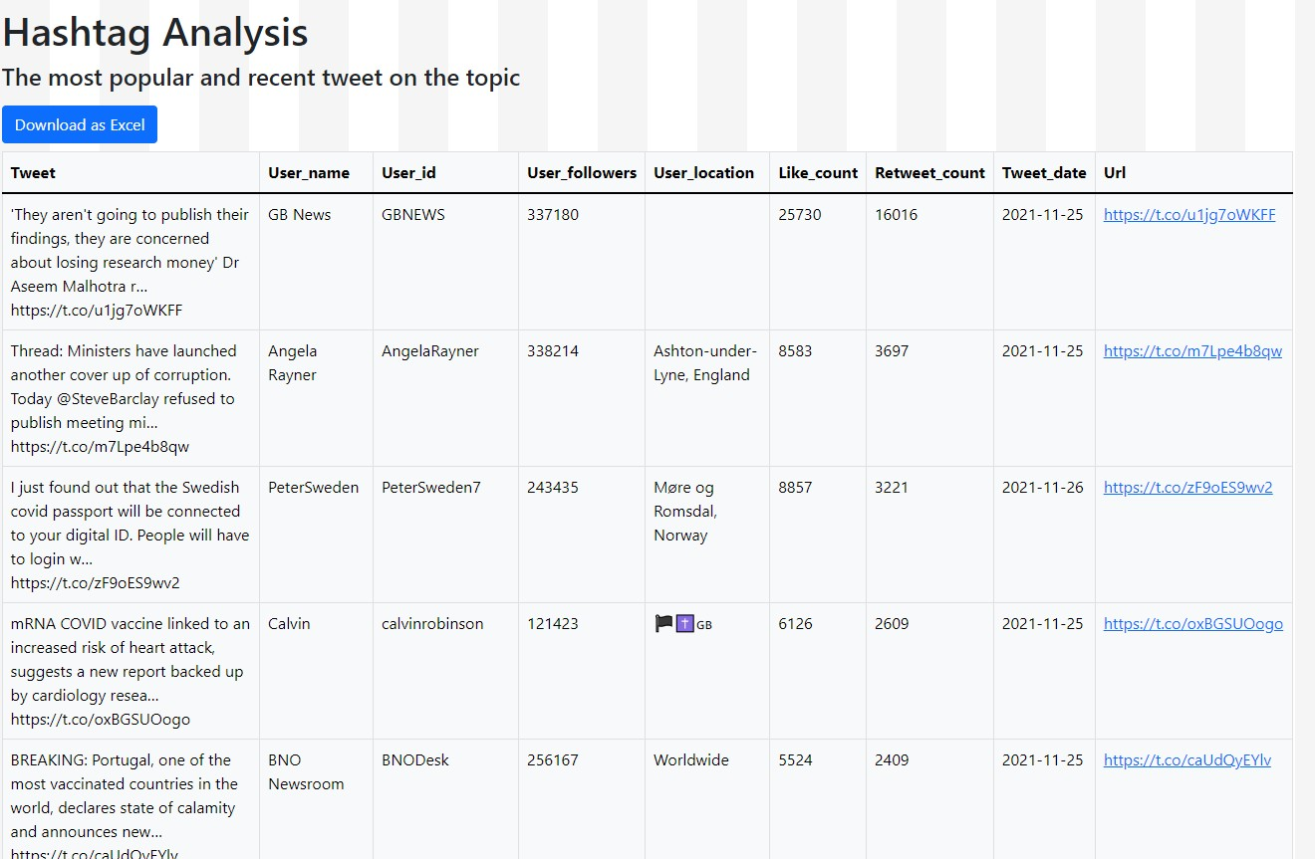

Sentiment analysis – Tweets categorized as positive negative and neutral. The percentages are displayed in a pie chart.

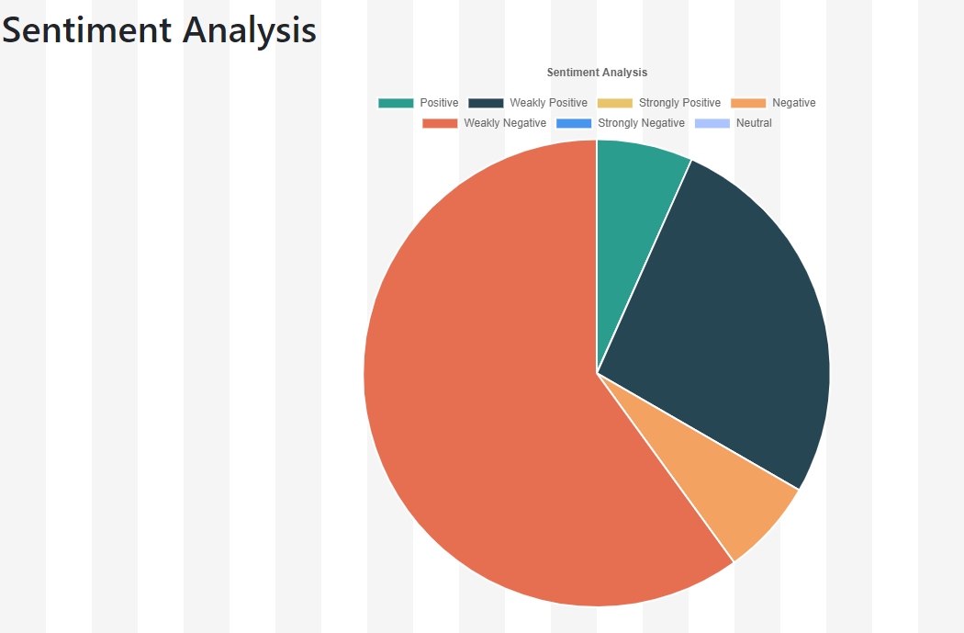

Interest analysis - From the tweets that the user liked, using Natural language processing, the tweets are categorised into categories and the user's recent interest domains are shown.

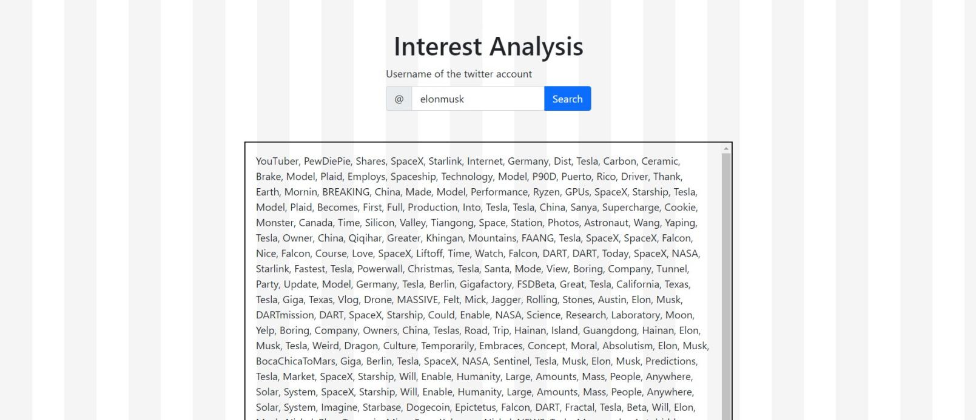

Targeted ADS - Targeted ADS

Given a business account or any account, the last 10 tweets posted by the user are considered and the users who liked them are analysed and ranked describing their interest in the post posted by the business account. The business admin can use this report to promote their product directly to those users by using the username and the account link provided from our analysis.

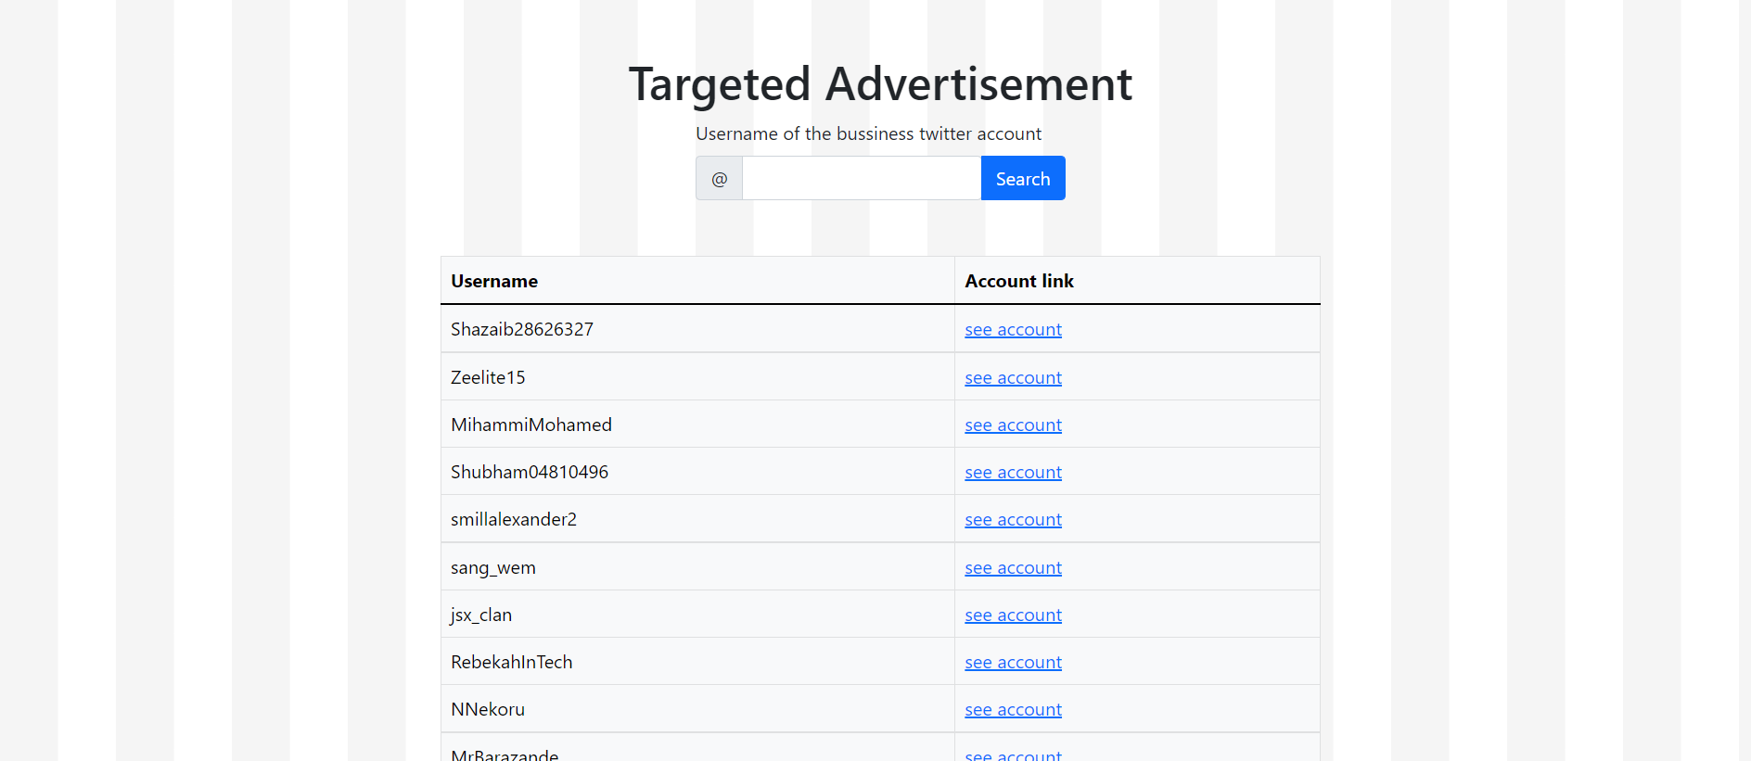

We also have session store, so that user can access the previously searched query in Tweet analysis

Github repository link - <https://github.com/Krithiik/Twitter_sentiment>

Google drive link -

https://drive.google.com/file/d/1H38xhEtnXEBH1OoEO_TsHDd xE2Cb0_z0/view?usp=sharing

Kindly copy and paste the link instead of clicking directly. There is some error due to hidden spaces.